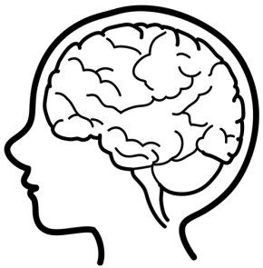**The BRAIN!**

Frontal lobe

Parietal lobe

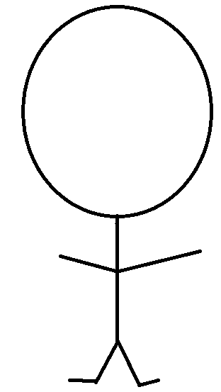

Draw the 5 senses!

Temporal lobe

Occipital lobe